Frank Watters & Mary Anne Houx Children’s Fund Mini-Grants

Fiscal Year

2023-2024

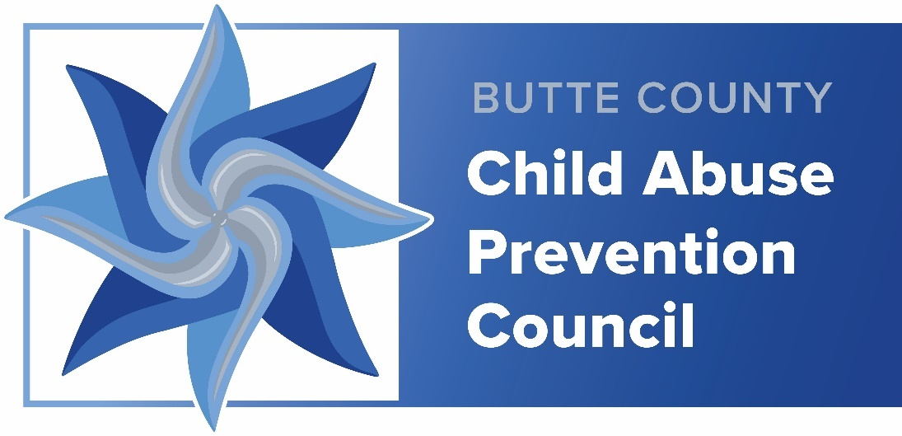

Facilitated through the

Child Abuse Prevention Council

of Butte County

Questions may be directed to Jolene Hausman
at 530.205.3066
or via e-mail at jolene@buttecountycapc.org

Application Requirements

About the Children’s Fund

The Frank Watters & Mary Anne Houx Children’s Fund was established in 1994 to
combat the high incidence of child abuse and neglect in Butte County and provide
additional funding for services to meet the needs of children and families in our area.
Frank Watters was an economics professor at Chico State University and Mary Anne
Houx was on the Butte County Board of Supervisors for many years. They both felt that
citizens want to help reduce child abuse and, if given the opportunity, would do so by
donating to a fund for the cause.

Citizens contribute to this fund by donation either via PayPal or by mail as instructed in
the insert in property tax bills. This has been a collaborative effort with the Child Abuse
Prevention Council, Children’s Services Coordinating Council and the Department of
Employment and Social Services of Butte County as well as other community
organizations. Numerous agencies and individuals donate time and money to the Frank
Watters & Mary Anne Houx Children’s Fund. Child Abuse Prevention
Council of Butte County, has been given the responsibility to disperse these funds to
help children and families in Butte County.

About the Child Abuse Prevention Council of Butte County

The Child Abuse Prevention Council (CAPC) of Butte County was established in 1975 and in 1989 was designated as the official Child Abuse Prevention Council of Butte County by the Board of Supervisors under the mandates of the California Welfare and Institutions Code Section 18965.

In accordance with Welfare & Institutions Code Section 18982.2, the role and responsibility of the Child Abuse Prevention Council of Butte County is to coordinate efforts to prevent child abuse by promoting healthy families. This is accomplished by the following efforts:

- Provide a forum for interagency collaboration, networking, problem-solving, cooperation and coordination in the prevention, detection, treatment and legal processing of child abuse cases.
- Encourage and facilitate education and training for the community and professionals in the detection, treatment and prevention of child abuse and neglect.
- Planning for the future by assessing needs and resources in preparation for improvement and expansion of services to children and families and recommend improvements in services to families and victims.
- Encourage and facilitate community support for child abuse and neglect programs.
- Educate parents: on ages and stages of growth and development of children; positive discipline techniques; attachment and empathy; assist with creating social connections for families and providing outreach of resources available to them.
- Promote public awareness of the abuse and neglect of children and the resources available for intervention and treatment.
- Support parents seeking recovery for drug and or alcohol abuse.

Our Mission Statement:
Butte County’s Child Abuse Prevention Council serves as a catalyst for change to prevent child abuse while building strong community partnerships through awareness, education and outreach.
Our Vision Statement:
Butte County’s Child Abuse Prevention Council vision is the elimination of child abuse in Butte County.

Funding Guidelines and Allocations for the

Frank Watters & Mary Anne Houx Children’s Fund Mini-Grant

Eligible Projects:

- Services must benefit residents of Butte County, limited to children birth to seventeen (17) years of age, and their families.
- Services must fit within the parameters of the goals of the CAPC.
- Only one mini-grant will be awarded per program, per fiscal year.
- Funds may be used for one-time events, consumable materials, new projects, or to enhance existing services.
- Funds must be used either to supplement existing programs or for new projects.
- Funds may not supplant existing programs or projects.

Applicants may apply for funds in one of the following three areas:

Prevention:

Services that prevent child maltreatment or neglect.

Treatment:

Services to support families to strengthen protective factors and reduce incidents of child maltreatment/neglect.

Match:

Services that have a financial match requirement that meet one of the above criteria. It is the proposer’s responsibility to verify that these funds can be used as “matching” funds.

Events/projects must incorporate at least one of the Five Protective Factors:

Parental Resilience
The ability to recover from difficult life experiences,
and often to be strengthened by and even transformed by those experiences.

Social Connections
The ability and opportunity to develop positive relationships that lessen stress
and isolation and help build a supportive network.

Knowledge of Parenting and Child Development
The ability to exercise effective parenting strategies to guide and know what to
expect as children develop in multiple domains (physical, cognitive, language,
and social and emotional)

Concrete Support in Times of Need
Access to supports and services that reduces stress and helps to make stronger families.

Social and Emotional Competence of Children
Family and child interactions that help children develop the ability to communicate clearly, recognize and regulate their emotion and establish and maintain relationships.

Projects that meet the applicant and project eligibility guidelines may apply for funding by completing the attached application. Applicants may submit a request to CAPC for funds up to $5,000.00. Complete or partial funding may be awarded. Generous donations allow for approximately $25,000.00 to be distributed for Mini Grants for the fiscal year 2023-2024.

Applicant Eligibility:

An eligible applicant must be a community or faith-based entity, not for profit organization, agency, college, school, or a municipality or unit of government located in Butte County with programs that serve the needs of at-risk children and families. Programs must be able to demonstrate effective support in providing child abuse prevention services.

Grantee Funding and Responsibilities:

Grantees must agree to the following:

- After receiving funds, grantees are required to track their grant-related activities and budget expenditures, including back up accounting (i.e. receipts) on an on-going basis.

- Mandatory Mid-Year and Final Reports as outlined herein will be required by January 31, 2024 and May 31, 2024 respectively.

- Grantees shall be prepared to offer a presentation sharing grant activities, progress and goals at a pre-arranged Child Abuse Prevention Council Meeting.

- Grantees will receive 50% of their total budget after their project has been approved for funding and presentation/reporting dates have been scheduled.

- Upon review and approval of the Mid-Year Summary Report (including Budget Form), the second, final payment of the grant funds will be issued.

- Grantees shall notify the Child Abuse Prevention Council as soon as possible if they are unable to fulfill the funded program requirements.

- Grantees shall return any unused portion of funding.

- Grantees will acknowledge the Butte County Children’s Fund administered by Butte County’s Child Abuse Prevention Council as a source of funds when promoting their event/program in print and social media. The logo will be provided for use.

- Grantees will provide the Council with a copy of the material displaying the designated logo via the Council email at info@buttecountycapc.org.

Failure to meet the Funding and Responsibilities outlined herein may disqualify the grantee from receiving the balance of funding at mid-year and/or future funding.

Application Instructions and Deadline:

Grant applications are available through the Child Abuse Prevention Council by accessing the Google-Drive or via written request to jolene@buttecountycapc.org. Any questions may also be directed to this email or by phone to 530.205.3066.

Applications that are incomplete, unsigned, or not received by the due date and time will be disqualified. Scoring information is detailed in each section with a total possible of 300 points:

- Cover Page & Commitment | 25 points
- Proposal Details | 200 points
- Budget Forms | 25 points
- Action Plan & Timeline | 50 points

The Child Abuse Prevention Council’s appointed Review Committee is comprised of individuals who meet the criteria for non-conflict of interest. They will review qualified proposals to render the awards. The Review Committee submits their results to the Council who votes to accept the recommendation for awarding the grants. Council members from agencies applying for funds must abstain from voting.

The Council reserves the right to reject any or all proposals or to modify the amount of funding requested if it is in the best interest of the Council to do so. The Council further reserves the right to request reimbursement of funds not used or applied outside of the scope of the agreed upon grant application without prior approval, and/or to refuse second payment for the same reason(s).

Applications must be summited electronically and must be received by 5:00pm, September 15, 2023

Email the document in pdf format to jolene@buttecountycapc.org. An email confirmation will be sent to you the same day.

You are advised to avoid last minute submittals pending unforeseen events, crises, technical difficulties, et cetera that may cause your organization to miss the deadline. Sorry, we can make no exceptions to the deadline date and time.

Award winners will be notified by email and announced at the regularly scheduled October meeting. 50% funds allocated will be released to the grantee(s) the week of
October 2-6, 2023.

Frank Watters & Mary Anne Houx Children’s Fund
Grant Application

- Cover Page & Commitment
The Cover Page & Commitment is scored at 0 to 25 points. Failure to accurately complete and sign this Page will disqualify an Application. If you have means to process a digital signature, that is acceptable (but not a typed signature). Otherwise, please scan a signed copy and forward with the rest of the Application.

Organization Name:
Project Title:
If applicable, please provide your IRS EIN number:
Project Contact:  Phone: | Fiscal Agent:  Phone:
Email:
Address:
Proposed Location of Event/Program:
Project Start Date: | Project End Date:
Amount Requested: $

I verify that our agency does not and shall not discriminate on the basis of race, color, religion (creed), gender, gender expression, age, national origin (ancestry), disability, marital status, sexual orientation, or military status, in any of its activities, services or operations. These activities include, but are not limited to, the provision of services, hiring and firing of staff, and selection of volunteers and vendors. We are committed to providing an inclusive and welcoming environment for all.

I verify that the content of this Application is correct and accurate and, if awarded, will abide by the Responsibilities outlined herein. It is recognized that failure to comply with said Responsibilities may result in the Child Abuse Prevention Council requesting funds being returned, delayed or denial of mid-year funding, and/or disqualification from further funding from the Frank Watters & Mary Anne Houx Children’s Fund.

________________________________________ ________________________
Name and Title of Applicant Agency

________________________________________ ________________________
Signature of Applicant Date

- Proposal Details
The Proposal Details section is worth a total of 200 points.

Instructions: Please address each of the following. If submitting your application on a separate form, please use the indicated identifier for each response (a through n). It is recommended that your responses be clear and concise. Responses are to be 12-point Ariel font.
Items a through h are to be scored at 0 to 5 points each.
- Briefly describe your agency’s mission and history. What programs do you provide? How long have you been providing them?

- Is someone in your organization a member of the Child Abuse Prevention Council of Butte County?
☐ Yes ☐ No
Name: ______________________ Email Address: ____________________
- Please list any qualifications (professional credentials, life experience and training) of the individual(s) responsible for the project activities?

- Have the individual(s) responsible for the project activities received training on trauma-informed care?
☐ Yes ☐ No
Please list trainings:

- Please list any partners you may plan to use and your relationship with them:

- Are you pursuing additional/other funding for this project?
☐ Yes
☐ No
If yes, please describe

- Please tell us about any in-kind contribution you may have for the project.

- Indicate in which service area you are requesting funding:
☐ Prevention
☐ Treatment Services to support families to strengthen protective factors and reduce incidents of child maltreatment/neglect.
☐ Match funds for other projects. It is the proposer’s responsibility to verify that these funds can be used as matching funds.
Items j through p are to be scored at 0 to 20 points each.
- Which Protective Factor(s) will your proposal address, and how?

- Please describe the individuals or communities to be served and in what town/city services will be implemented.

- Please describe the purpose and objectives of your proposal:

- Please describe the problem or need which you seek to solve:

- Please provide details on the design and strategy to address the problem or need:

- What program or specific curriculum will be used?

- Please indicate if this program/curriculum is a
☐ Promising practice
☐ Evidenced-based practice
☐ Evidence supported practice
☐ Not applicable If your proposal utilizes an unresearched approach, please explain your rationale for choosing this method:
- Please describe measurable outcomes and how you intend to report the effectiveness:

- Budget From
The Budget Form is scored at 0 to 25 points.

Organization Name:

Project Title:

Budget Categories | Item/Explanation | Cost Per Unit | Amount
Materials/
Supplies*

Equipment
Travel

Salaries
Other

Total Proposed Budget

*Please be advised that as we are unable to fund the purchase of gift cards as part of the mini-grant.

A completed Budget Form must be submitted with each Application. Add additional pages to this form only if/as needed.

Please access and use this same form for mid-year and final reporting.

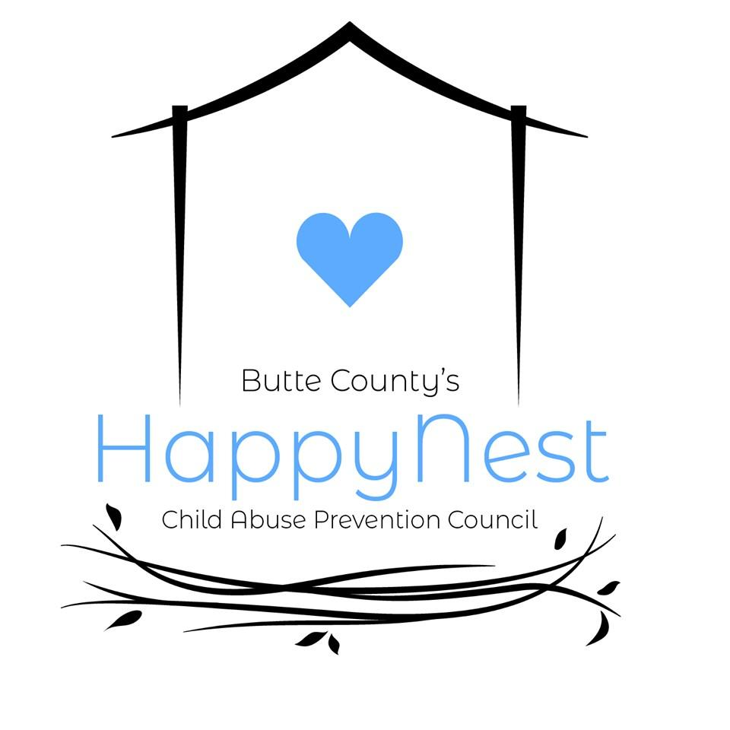
IV. Action Plan and Timeline
The Action Plan and Timeline is scored at 0 to 50 points.

Organization Name:

Project Title:

Project Activities | Individual(s)  Responsible | Completion Date(s) | Evidence of  Effectiveness/Measured Outcomes

A completed Action Plan & Timeline form must be submitted with each Application. Add additional pages to this form only if/as needed. Access this same form for mid-year and final reporting.

Check appropriate box:
- September 15, 2023 - Application Action Plan
- January 31, 2024 – Mid-Year Report
- May 31, 2024 - Final Report Completed by: ___________________________________
Signature

OCAP requested information:

- What languages were the programs provided in?

 | White (non-Hispanic) | Hispanic or Latino | Black or African American | Asian | American Indian or Alaska Native | Native Hawaiian or Pacific Islander | Two or More Race
# of Children Served
# of Children with disabilities served
# of Families
# Parents/caregivers

Indicate the special population that received services as a result of the Watters & Houx Mini-grants.
- Black, Indigenous, People of Color (BIPOC)
- LGBTQ +youth, children and families
- Communities historically underserved and/or marginalized
- Communities adversely affected by persisted poverty.
Reporting Instructions

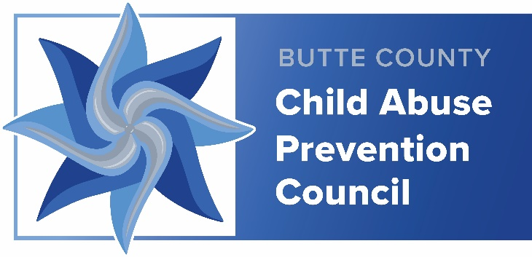

Reporting Instructions

Important Dates:

January 31, 2024 –Mid-Year Summary Report. Please provide a brief update and the mandatory Mid-Year Summary Report. The purpose of the report is to evaluate the success and challenges of your project or event to date by addressing the following:

- Using the Action Plan & Timeline to demonstrate program implementation and measurable outcomes of your success.

- Complete the Budget Form showing costs to date.

- Complete the OCAP requested information forms.

- Provide a copy of printed materials (flyers, handouts, and/or educational materials) used for the grant project if applicable.

- Send photos and release forms if applicable. (Release forms will be provided for permission for possible use of photos on social media.)

- Other comments or feedback.

May 31, 2024 – Mandatory Final Report. Please report your successes and submit the mandatory Final Report. The purpose of the report is to evaluate the overall achievements and challenges of your project or event by addressing the following:

- Using the Action Plan and Timeline to demonstrate program implementation and measurable outcomes of your success.

- Complete the final Budget Form showing total, overall costs, including receipts/invoices/documentation of costs.

- Complete the OCAP requested information forms.

- Provide a copy of printed materials (flyers, handouts, and/or educational materials used for the grant project if applicable.

- Send photos and release forms if applicable. (Release forms will be provided for permission for possible use of photos on social media.)

- How did the program/event contribute to one or more of the Five Protective Factors that help to strengthen families?

- Provide at least one story about how this mini-grant improved the life of a child or family living in Butte County.

- Describe any lessons learned from this project that could be useful to CAPC or others applying for mini grants.

- Other comments or feedback.

A Scheduled Presentation outlining/demonstrating the successes of your program may be requested.

Other Instruction

- Date and sign your complete report verifying its truthfulness and accuracy.

- Questions or concerns should be directed to Jolene Hausman 530.205.3066 or jolene@buttecountycapc.org.

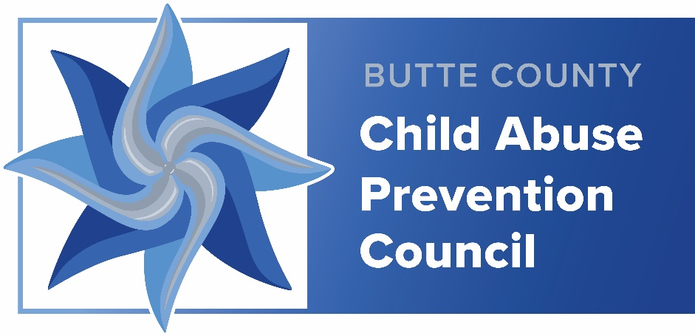

Children’s Visual/Audio Image Release Form

I grant permission to Butte County’s Child Abuse Prevention Council (CAPC) to take and use visual/audio images of me for use in social media and/or website. Visual/audio images are any type of recording, including photographs, digital images, drawings, renderings, voices, sounds, video recordings, audio clips or accompanying written descriptions. CAPC has the right to alter images and/or film footage, which may include alterations via cropping, change in brightness/contrast, and other standard technical adjustments, and creating composite or artistic representations.

I understand that these images and/or video may be posted on the World Wide Web. I agree that CAPC owns the images/video and all rights related to them. I waive any right to inspect or approve the finished images or any printed or electronic matter that may be used with them.

I release CAPC and its employees and agents, including any firm authorized to publish and/or distribute a finished product containing the images, from any claims, damages or liability which I may ever have in connection with the taking of use of the images and/or video.

I have read this release before signing, I understand its contents, and I freely accept the terms.

_______________________________
Child’s Name

_______________________________ _______________________________
Parent/Legal Guardian’s Name Date

_______________________________ _______________________________
Signature of Parent/Legal Guardian Telephone or email address

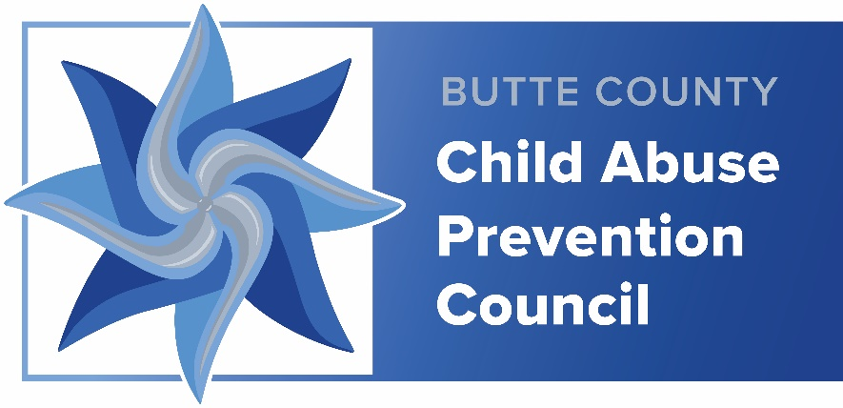

Adult’s Visual/Audio Image Release Form

I grant permission to Butte County’s Child Abuse Prevention Council (CAPC) to take and use visual/audio images of me for use in social media and/or website. Visual/audio images are any type of recording, including photographs, digital images, drawings, renderings, voices, sounds, video recordings, audio clips or accompanying written descriptions. CAPC has the right to alter images and/or film footage, which may include alterations via cropping, change in brightness/contrast, and other standard technical adjustments, and creating composite or artistic representations.

I understand that these images and/or video may be posted on the World Wide Web. I agree that CAPC owns the images/video and all rights related to them. I waive any right to inspect or approve the finished images or any printed or electronic matter that may be used with them.

I release CAPC and its employees and agents, including any firm authorized to publish and/or distribute a finished product containing the images, from any claims, damages or liability which I may ever have in connection with the taking of use of the images and/or video.

I have read this release before signing, I understand its contents, and I freely accept the terms.

________________________________ ________________________________
Participant's Name Date

________________________________ ________________________________
Participant’s Signature Telephone or email address

